**APLIKASI ATM SEDERHANA**

**DENGAN BAHASA PEMOGRAMAN *C++***

oleh:

FELIX ANDREAS (1810631170119)

ROBBY FAISHAL BARI (1810631170156)



**PROGRAM STUDI TEKNIK INFORMATIKA**

**FAKULTAS ILMU KOMPUTER**

**UNIVERSITAS SINGAPERBANGSA KARAWANG**

**KARAWANG**

**2019**

1. **Anggota Kelompok dan masing-masing tugas di dalam project**

**Source Code Program : - Felix Andreas**

* **Robby Faishal Bari**

**Flowchart : - Felix Andreas**

* **Robby Faishal Bari**

**Makalah : - Felix Andreas**

* **Robby Faishal Bari**

**PPT : - Felix Andreas**

**Fasilitas Utama :**

1. Menampilkan form masukkan pin
2. Menampilkan menu utama
3. Menampilkan cek saldo
4. Menampilkan transfer
5. Menampilkan tarik tunai
6. Menampilkan setor tunai

**Fasilitas Tambahan :**

1. Fitur back & exit

**Bisnis Proses Aplikasi :**

Aplikasi ATM sederhana ini menggunakan bahasa pemrograman basis *C++* dan menggunakan system main utama yang menampilkan menu yaitu : cek saldo, transfer, penarikan tunai, penyetoran tunai, dan menu untuk exit. Kekurangannya Aplikasi ATM sederhana jika salah memasukkan pin lebih dari 3 kali maka kartu atm tidak terblokir, seharusnya jika salah memasukkan pin lebih dari 3 kali sudah diblokir. Kekurangan lainnya yaitu atm ini tidak menyediakan fitur membeli pulsa, mengisi paket data, membayar tagijhan listrik, membayar tagihan air, dan lain-lain.

Flowchart

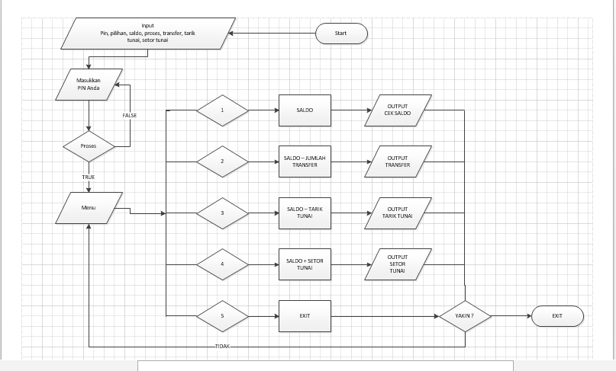

**Source Code** :

#include <iostream>

#include <string>

#include <windows.h>

#include <cstdlib>

using namespace std;

main()

{

system("Color 1A");

cout<<endl;

string sambutan="\t\t>>>>>>>>>>SELAMAT DATANG DI ATM SWADIKAP UWWWAUUU<<<<<<<<<<\n\n";

for (int x=0;x<=sambutan.length();x++){

cout<<sambutan[x];

for (double y=0;y<=9990000;y++){

}}

cout<<endl<<endl;

system("color 1f");

int pin=1234;

cout<<"========================================================="<<endl;

cout<<"||| SELAMAT DATANG DI ATM SWADIKAP UWWWAUUU |||"<<endl;

cout<<"||| PECAHAN RP 50000 |||"<<endl;

cout<<"=========================================================";

cout<<"\nMasukkan Pin Anda :";

cin>>pin;

while (!(pin==1234))

{

system("CLS");

cout<<"========================================================="<<endl;

cout<<"||| SELAMAT DATANG DI ATM SWADIKAP UWWWAUUU |||"<<endl;

cout<<"||| PECAHAN RP 50000 |||"<<endl;

cout<<"=========================================================";

cout<<"\n";

cout << "Pin yang anda masukkan salah" << endl;

cout << "\n\tMasukkan Pin : " ;

cin >> pin;

}

if (pin==1234)

{

cout << "Pin yang anda masukkan benar" << endl;

}

else

{

system("CLS");

cout << "Pin yang anda masukkan salah" << endl;

cout << "Masukkan Pin" << endl;

cin >> pin;

}

int pilihan, saldo=1000000, tf, tn, sisa, tujuan, top;

menu :

system("cls");

cout<<"========================================================="<<endl;

cout<<"||| ATM SWADIKAP UWWWAUUU |||"<<endl;

cout<<"||| PECAHAN RP 50000 |||"<<endl;

cout<<"=========================================================";

cout<<"\n";

cout<<"\tMENU : \n\n";

cout<<"\t\t1. Cek Saldo \n";

cout<<"\t\t2. Transfer \n";

cout<<"\t\t3. Tarik Tunai \n";

cout<<"\t\t4. Setor Tunai \n";

cout<<"\t\t5. Exit \n\n";

cout<<"\t Masukkan Pilihan Anda :";

cin>>pilihan;

switch(pilihan)

{

case 1:

{

menu1:

system("cls");

char a;

cout<<"========================================================="<<endl;

cout<<"||| ATM SWADIKAP UWWWAUUU |||"<<endl;

cout<<"||| PECAHAN RP 50000 |||"<<endl;

cout<<"=========================================================";

cout<<"\n";

cout<<" Saldo Anda : Rp. "<<saldo<<endl<<endl<<endl;

cout<<"\n";

cout<<" Kembali Ke Menu Utama y/n :"; cin>>a;

if (a=='y'||a=='Y')

{

goto menu;

}

else if(a=='n'||a=='N')

{

goto menu1;

}

break;

}

case 2:

{

menu2:

system("cls");

char a;

cout<<"========================================================="<<endl;

cout<<"||| ATM SWADIKAP UWWWAUUU |||"<<endl;

cout<<"||| PECAHAN RP 50000 |||"<<endl;

cout<<"=========================================================";

cout<<"\n";

cout<<" Transfer \n";

cout<<"\n";

cout<<" Masukkan Rekening Tujuan : "; cin>>tujuan;

cout<<"\n";

cout<<" Masukkan Jumlah Transfer : Rp. ";

cin>>tf;

if (saldo>=tf)

{

}

else

{

while (!(saldo>=tf))

{

system("cls");

cout<<"========================================================="<<endl;

cout<<"||| ATM SWADIKAP UWWWAUUU |||"<<endl;

cout<<"||| PECAHAN RP 50000 |||"<<endl;

cout<<"=========================================================";

cout<<"\n";

cout << "Maaf Saldo Anda Kurang" << endl;

cout<<"\n";

cout<<" Masukkan Rekening Tujuan : ";

cin>>tujuan;

cout<<"\n";

cout<<"Masukkan jumlah transfer : Rp. ";

cin >> tf;

}

}

cout<<"\n";

cout<<"Transaksi berhasil !"<<endl;

cout<<"\n";

sisa=saldo-tf;

cout<<" Jumlah Saldo Saat Ini : Rp. "<<sisa<<endl;

cout<<"\n";

cout<<"\nKembali Ke Menu Utama y/n :"; cin>>a;

if (a=='y'||a=='Y')

{

saldo=saldo-tf;

goto menu;

}

else if(a=='n'||a=='N')

{

goto menu2;

}

break;

}

case 3:

{

menu3:

system("cls");

char a;

cout<<"========================================================="<<endl;

cout<<"||| ATM SWADIKAP UWWWAUUU |||"<<endl;

cout<<"||| PECAHAN RP 50000 |||"<<endl;

cout<<"=========================================================";

cout<<"\n";

cout<<" Tarik Tunai \n";

cout<<"\n";

cout<<" Masukkan Jumlah Yang Akan Ditarik : Rp. ";

cin>>tn;

if (saldo>=tn)

{

}

else

{

while (!(saldo>=tn))

{

system("cls");

cout<<"========================================================="<<endl;

cout<<"||| ATM SWADIKAP UWWWAUUU |||"<<endl;

cout<<"||| PECAHAN RP 50000 |||"<<endl;

cout<<"=========================================================";

cout<<"\n";

cout << "Maaf Saldo Anda Kurang" << endl;

cout<<"\n";

cout<<"Masukkan jumlah penarikan: Rp. ";

cin >> tn;

}

}

sisa=saldo-tn;

cout<<"\n";

cout<<" Sisa Saldo Sekarang : Rp. "<<sisa<<endl;

cout<<"\n";

cout<<" Silahkan Ambil Uang Anda, Jgn Lupa Sedekah"<<endl;

cout<<"\nKembali Ke Menu Utama y/n :"; cin>>a;

if (a=='y'||a=='Y')

{

saldo = saldo-tn;

goto menu;

}

else if(a=='n'||a=='N')

{

goto menu3;

}

break;

}

case 4:

{

menu4:

system("cls");

char a;

cout<<"========================================================="<<endl;

cout<<"||| ATM SWADIKAP UWWWAUUU |||"<<endl;

cout<<"||| PECAHAN RP 50000 |||"<<endl;

cout<<"=========================================================";

cout<<"\n";

cout<<" Setor Tunai \n";

cout<<"\n";

cout<<" Masukkan Jumlah yang Akan disetor : Rp. "; cin>>top;

cout<<"\n";

sisa=saldo+top;

cout<<" Anda Berhasil Menyetor ! \n";

cout<<"\n";

cout<<" Jumlah saldo saat ini : Rp. "<<sisa<<endl;

cout<<"\n";

cout<<"\nKembali Ke Menu Utama y/n :"; cin>>a;

if (a=='y'||a=='Y')

{

saldo=saldo+top;

goto menu;

}

else if(a=='n'||a=='N')

{

goto menu4;

}

break;

}

case 5:

{

char a;

system("cls");

cout<<"========================================================="<<endl;

cout<<"||| ATM SWADIKAP UWWWAUUU |||"<<endl;

cout<<"||| PECAHAN RP 50000 |||"<<endl;

cout<<"=========================================================";

cout<<"\n";

cout<<"Apakah Anda Yakin Akan Keluar : y/n \n";

cin>>a;

if (a=='y'||a=='Y')

{

cout<<"\n";

cout<<"Terimakasih telah menggunakan ATM SWADIKAP UWWWAUUU";

exit (0);

}

else if(a=='n'||a=='N')

{

goto menu;

}

}

}

}

**SCREENSHOOT:**

